
a
Company
Logotype

Cone Beam Computed Tomography- Report



Porur Dental X-rays & CBCT

Patient Name : Mrs. Veeramani | Date of Report : 16.06.2024
Age/ Gender : 73 years/ Female | Region of Interest : CBCT Maxilla
Referring doctor: Dr. Hemachandran | Indication : Implant assessment
Clinical Notes: Nil
PATIENT INFORMATION

CBCT- Maxilla provided
CBCT – IMAGE DETAILS

RADIOGRAPHIC INTERPRETATION

- Completely missing crown and root portion in relation to 16, 17, 26, 27, 28.
- Root stumps: 18, 24, 25
- The maxillary alveolar ridge is present with normal trabecular pattern.
- In relation to 14, 15 presence of hyperdense restorative material involving the crown and extending into the pulp canal upto the middle third of the roots is evident.

IMPLANT ASSESSMENT

 | 21 region | 24 region
Sub-Crestal | 4.2 | 8.17
Mid- Crestal | 4.15 | 7.48
Distance between the alveolar ridge and Floor of the Nasal cavity (in mm) | 20.68 | 16.88

 | 16 region | 17 region | 25 region | 26 region | 27 region
Sub-Crestal (in mm) | 6.6 | 8.22 | 8.57 | 6.77 | 9.94
Mid- Crestal (in mm) | 9.17 | 10.62 | 9.34 | 9.72 | -
Distance between the alveolar ridge and floor of the maxillary sinus (in mm) | 5.55 | 7.76 | 8.37 | 9.1 | 5.47

RADIOGRAPHIC IMPRESSION

- Partially edentulous maxillary arch.
- Root stumps: 18, 24, 25

Kindly correlate with clinical findings


IMAGES FOR REFERENCE

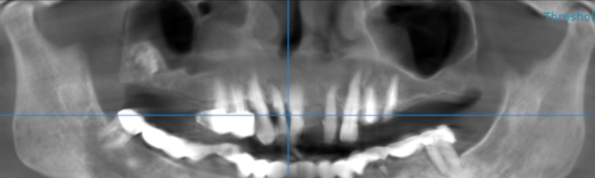

3-DIMENSIONAL VIEW

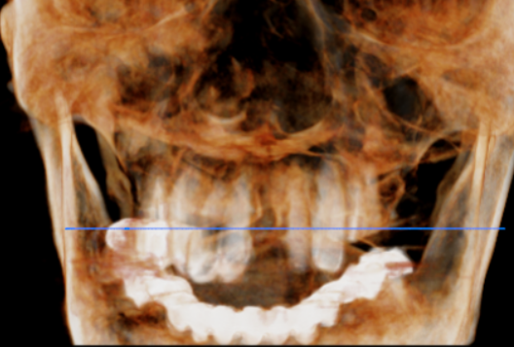

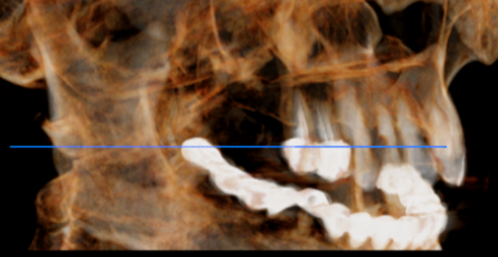
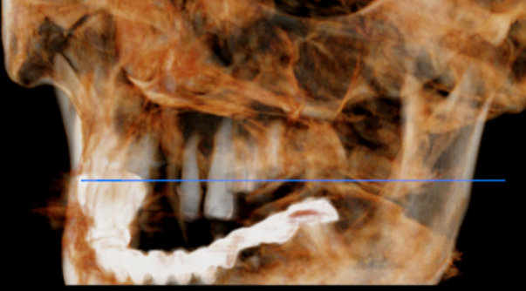

CROSS SECTIONAL VIEW

16 region | 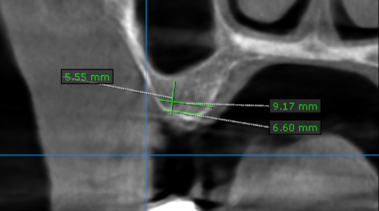
17 region | 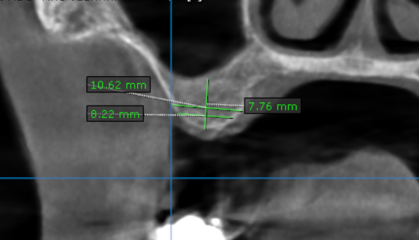
21 region | 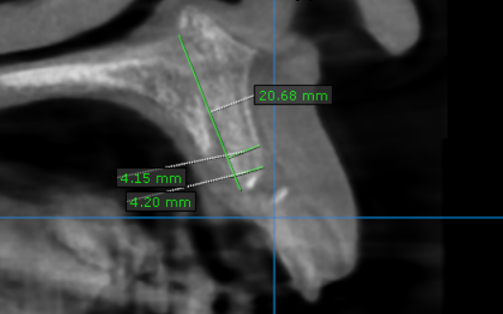
24 region | 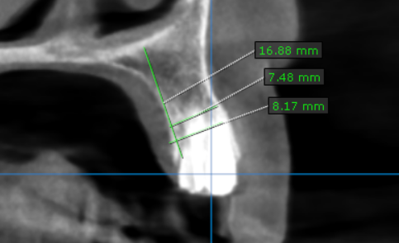
25 region | 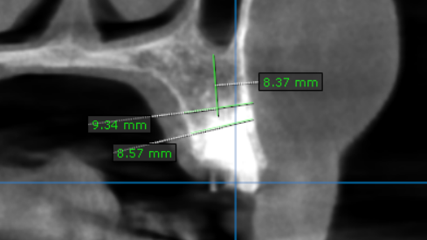
26 region | 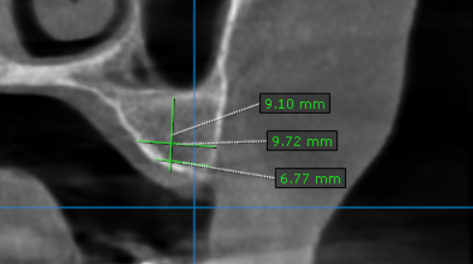
27 region | 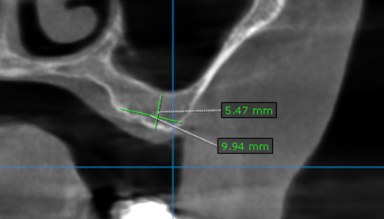

**** End of report ****

